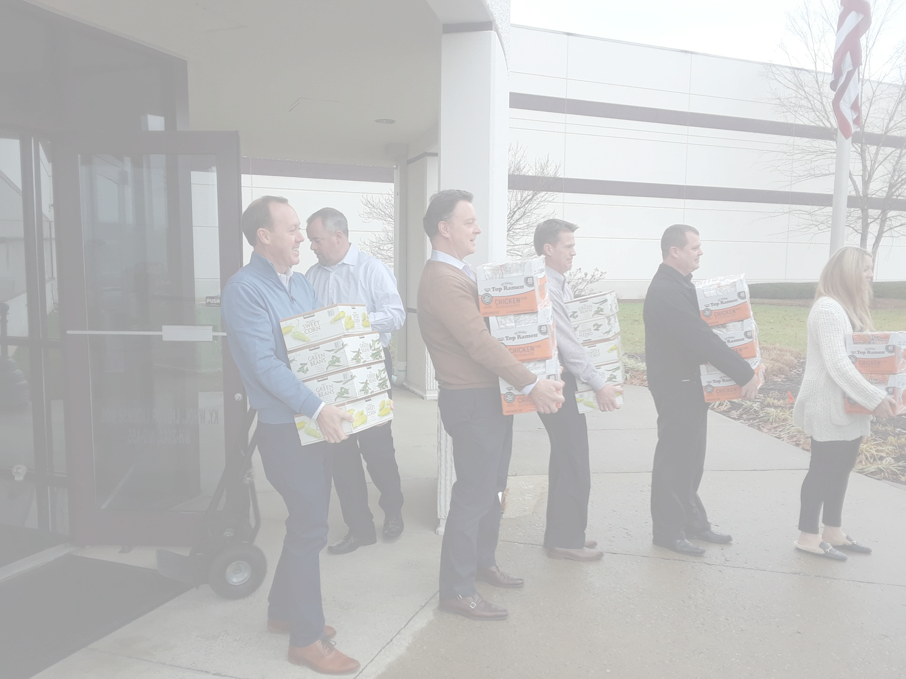 | CONTACT US  (502) 894-9999  kyharvest@win.net  KYHarvest.com  7705 National Turnpike  Louisville, KY 40214 |  | “Kentucky Harvest is a priceless and viable part of our mission. We are blessed to work with Marc Curtis and his staff.”  -Chuck Mattingly  Operations Director of the Franciscan Kitchen | KENTUCKY HARVEST | *Insert Logo
 | Since 1987, Kentucky Harvest has been collecting leftover and non-perishable food from resturants, schools, and churches. These donations are delivered to shelters and soup kitchens in Kentuckiana.  We are a logistics organization, meaning donations are never stored in a warehouse, rather, they are transported directly to those in need. |  | WHO WE SERVE  Every year, we deliver over 2 million pounds of donated to 84 recipient organizations in Louisville and Southern IN!  *Insert picture of recipient |  | HOW YOU CAN HELP  INDIVIDUALS  Individuals can volunteer to pick-up or deliver donations.  GROUPS  Organizations can host canned food drives, donate perishable food, or volunteer to deliver.  FINANCIALLY  Monetary donations will allow for continued operations, including transportation and office expenses.

*INSERT LOGO

WHO WE ARE

